Setup one slave machine for Jenkins

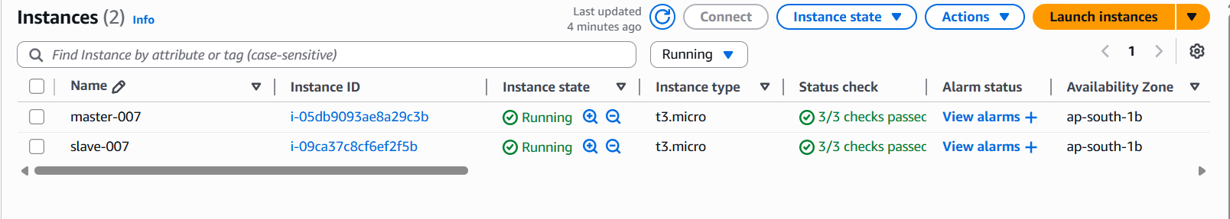
- Launch 2 instances for master and slave.

In MASTER,
- ssh -i "your-key.pem" ec2-user@<MASTER_PUBLIC_IP>
- sudo dnf update -y
- sudo dnf install java-17-amazon-corretto -y
- java -version
- sudo wget -O /etc/yum.repos.d/jenkins.repo \https://pkg.jenkins.io/redhat-stable/jenkins.repo
- sudo rpm --import https://pkg.jenkins.io/redhat-stable/jenkins.io-2023.key
- sudo dnf install jenkins -y
- sudo systemctl enable jenkins
- sudo systemctl start jenkins
- sudo systemctl status Jenkins
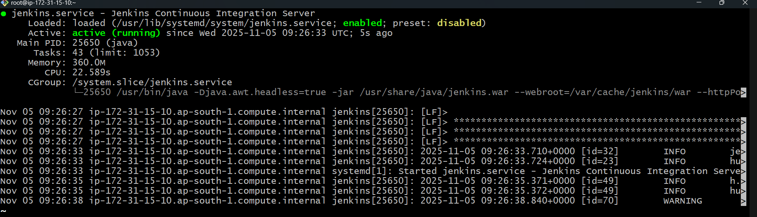
- Copy ip address of master and paste it on browser :8080 port
To unlock Jenkins cat//var/lib/jenkins/secrets/initialAdminPassword
- You will get the key 48f90dbdfee940fa82fc164a36345a57
- Install suggested plugins in it.
- Create admin user and reset the password
- Finish

IN SLAVE:-

- Same install java as above.
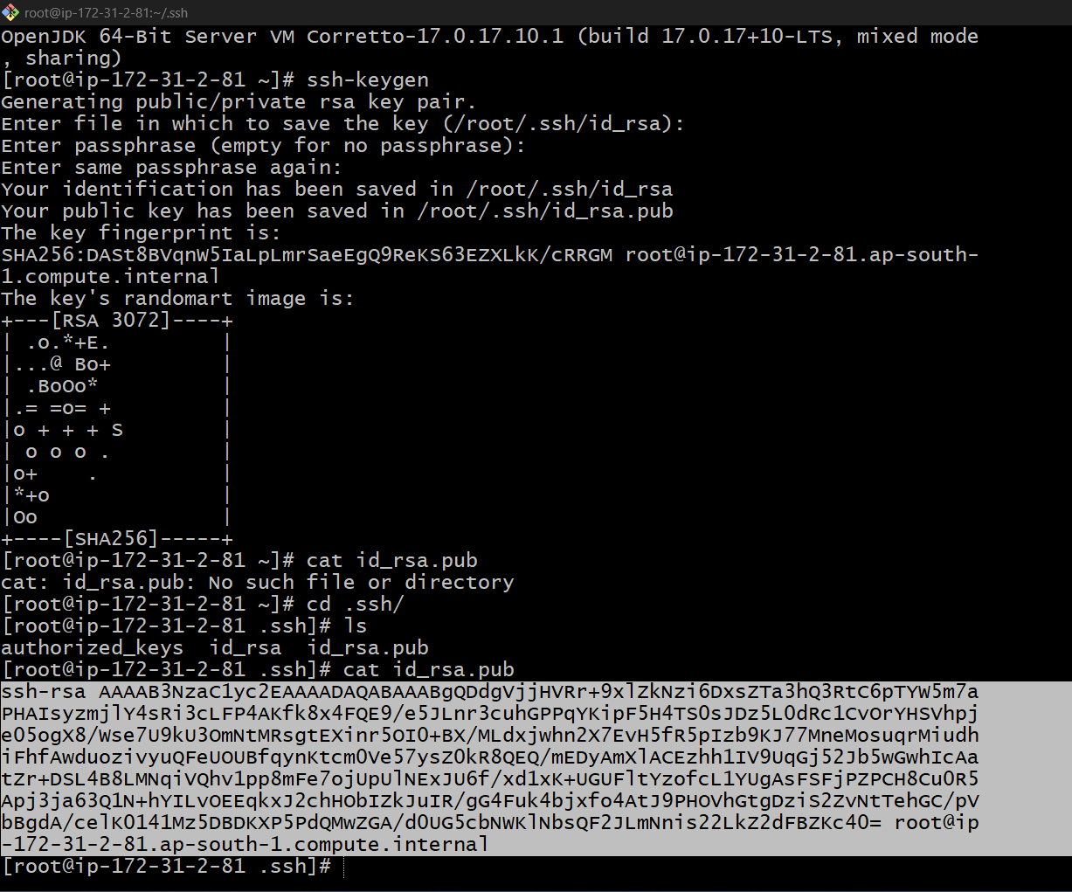

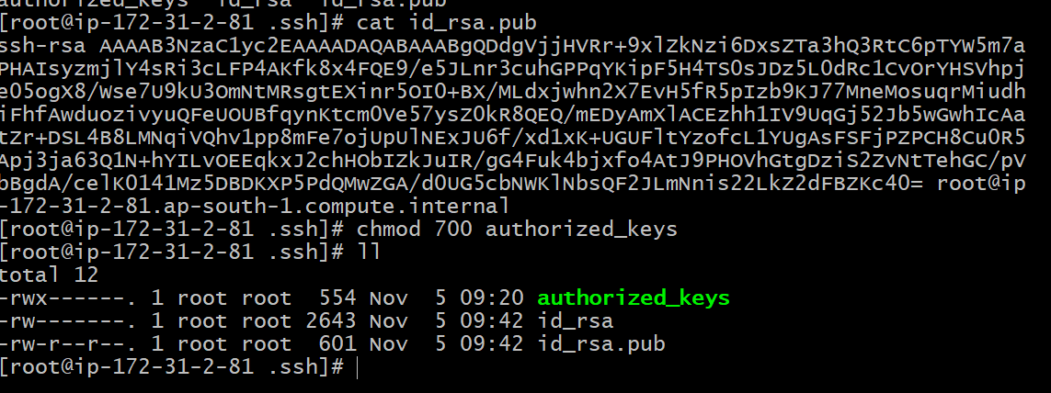

Now, go to master:-
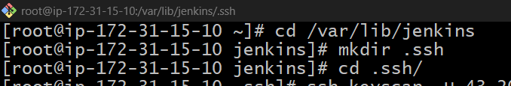

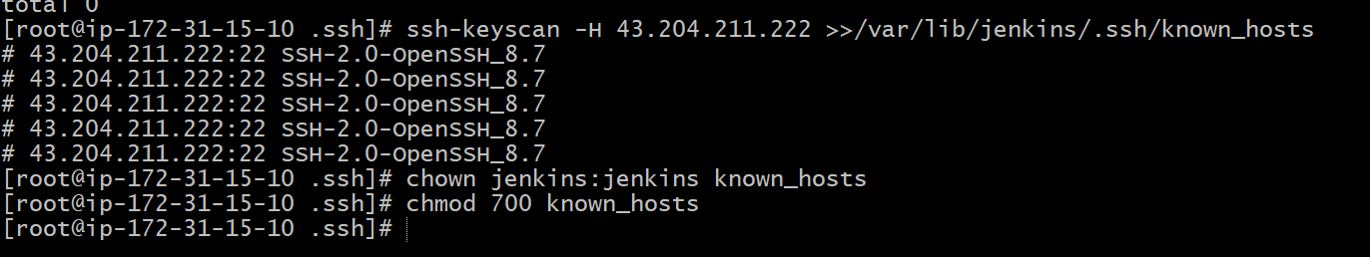

Now Go to Jenkins GUI;
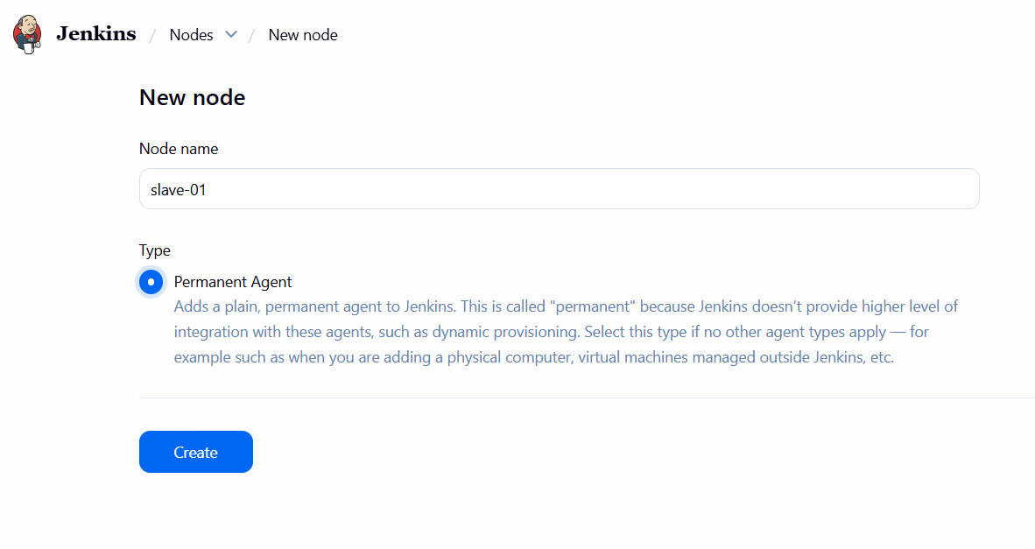
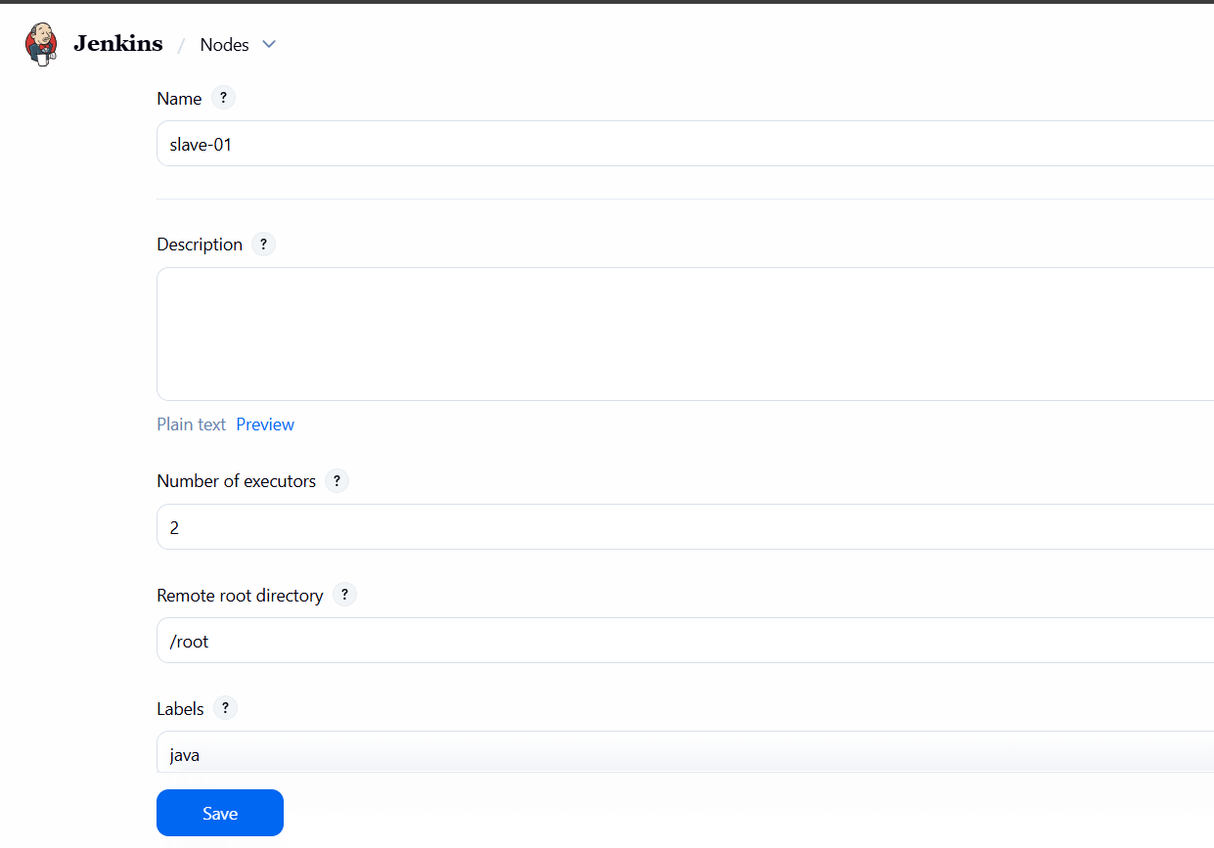
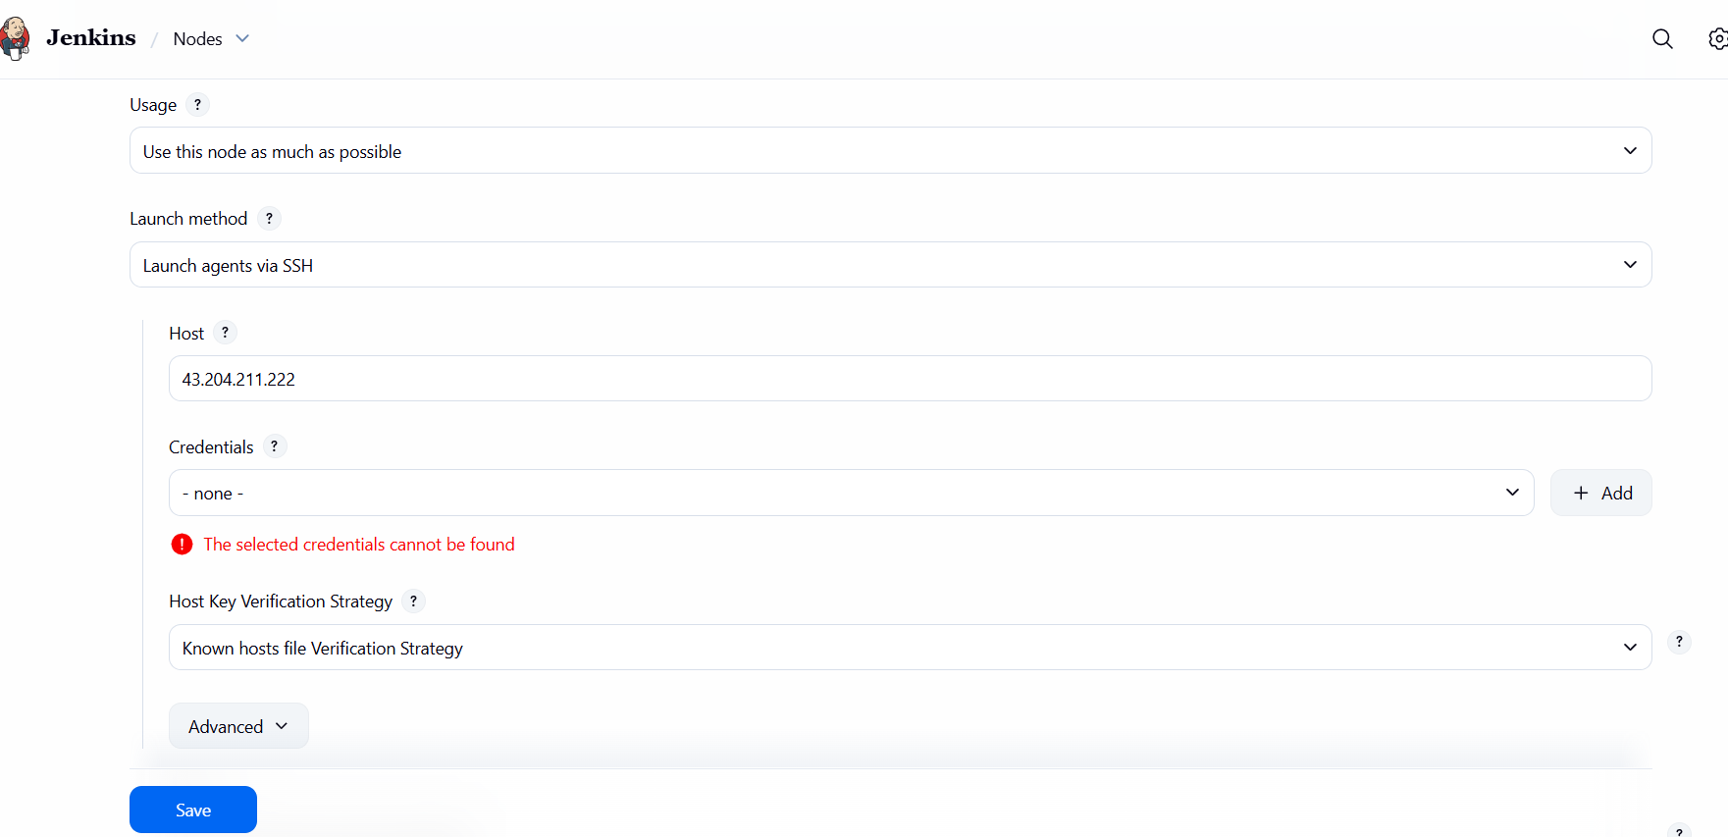

Now add credentials by copying the pem key ex:- cat Mumbai.pem.

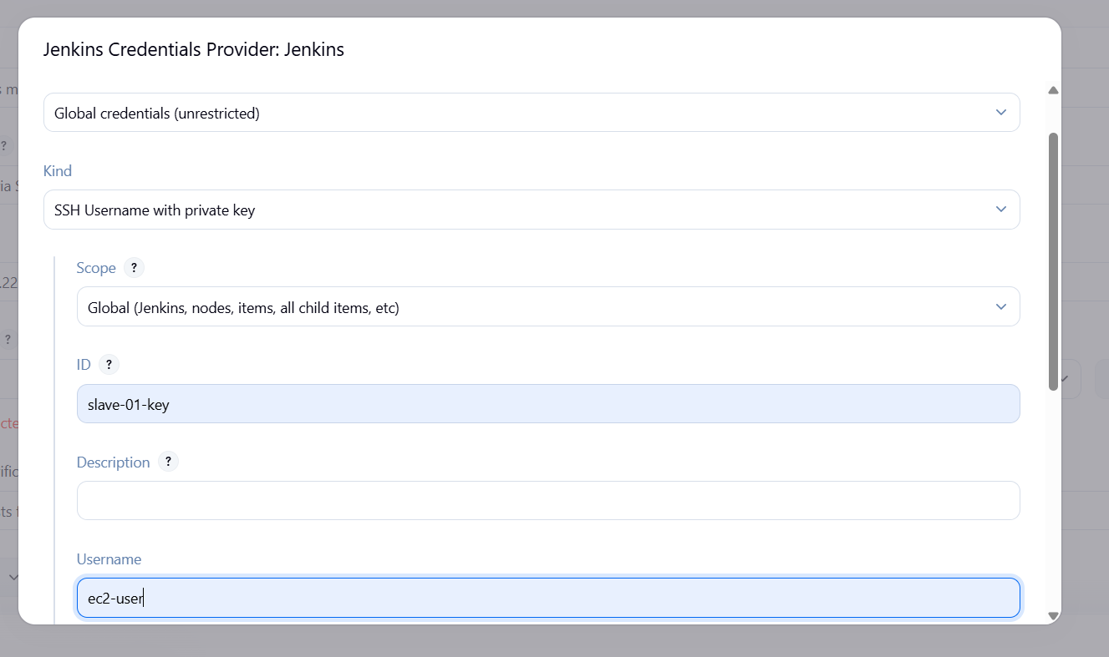

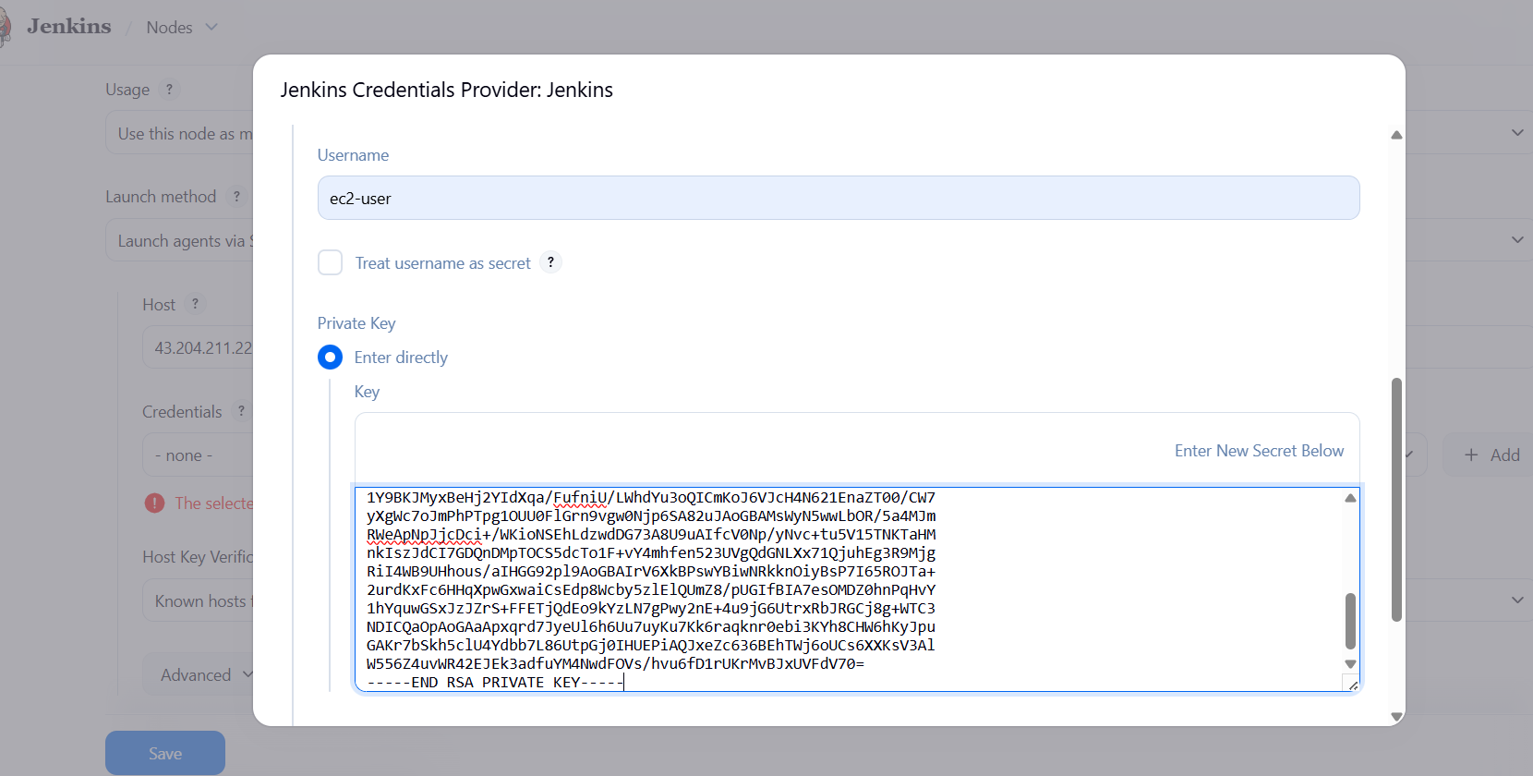

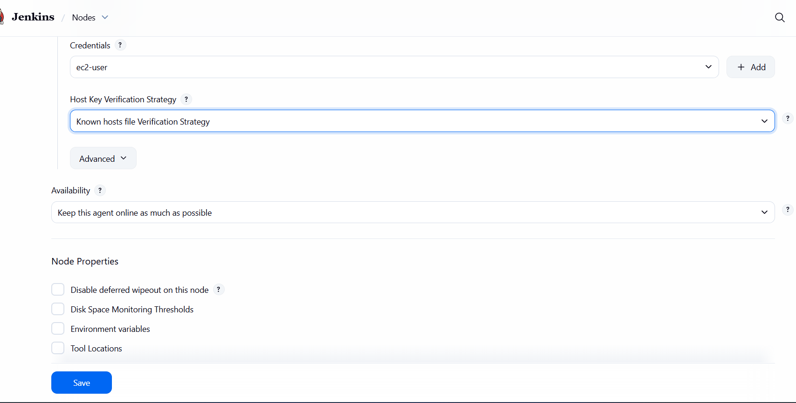

Save and go to slave cli and do the permission changes.
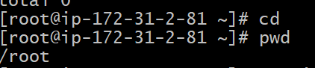

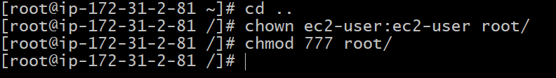

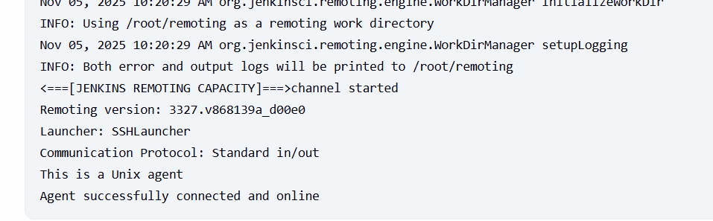

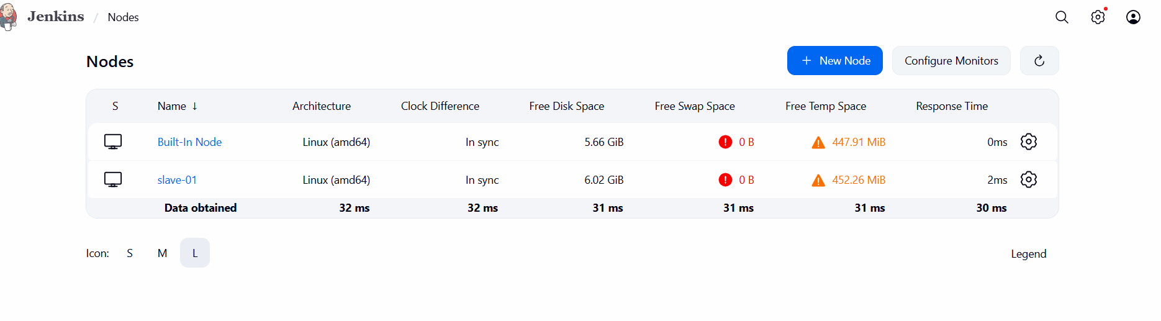

Test with a Pipeline
Create a new Pipeline Job → paste this:

pipeline {
agent { label 'java' }

stages {
stage('Build') {
steps {
sh 'hostname'
sh 'java -version'
echo 'Running successfully on Amazon Linux 2023 Slave!'
}
}
}
}

